**ROLL N0 :23BCL021**

**NAME: KARAN SAHU**

**BATCH : D1C3**

**Q1) You are a cashier at a grocery store and you need to write a C program that calculates and prints the total bill for a customer. The program should declare and initialize four variables of different data types: int, float, char, and double. The int variable should store the number of items purchased by the customer, the float variable should store the tax rate, the char variable should store the currency symbol, and the double variable should store the subtotal amount before tax. The program should also calculate and print the total amount after tax using the appropriate format specifiers in the printf() function. For example, %d for int, %f for float, %c for char, and %lf for double.**

**Hint:- Assume that the number of items is 5, the tax rate is 0.07, the currency symbol is ‘$’, and the subtotal amount is 23.45 are the inputs taken from user. The output will be as shown below: - Number of items: 5 Tax rate: 0.07 Subtotal: $23.45 Total: $25.09**

CODE :

#include <stdio.h>

int main()

{

int numItems;

float taxRate;

char currencySymbol;

double subtotal;

printf("Enter the number of items purchased: ");

scanf("%d", &numItems);

printf("Enter the tax rate (as a decimal): ");

scanf("%f", &taxRate);

printf("Enter the currency symbol: ");

scanf(" %c", &currencySymbol);

printf("Enter the subtotal amount before tax: $");

scanf("%lf", &subtotal);

double totalAmount = subtotal + (subtotal * taxRate);

printf("Number of items: %d\n", numItems);

printf("Tax rate: %.2f\n", taxRate);

printf("Currency symbol: %c\n", currencySymbol);

printf("Subtotal: $%.2lf\n", subtotal);

printf("Total amount after tax: %c%.2lf\n", currencySymbol, totalAmount);

return 0;

}

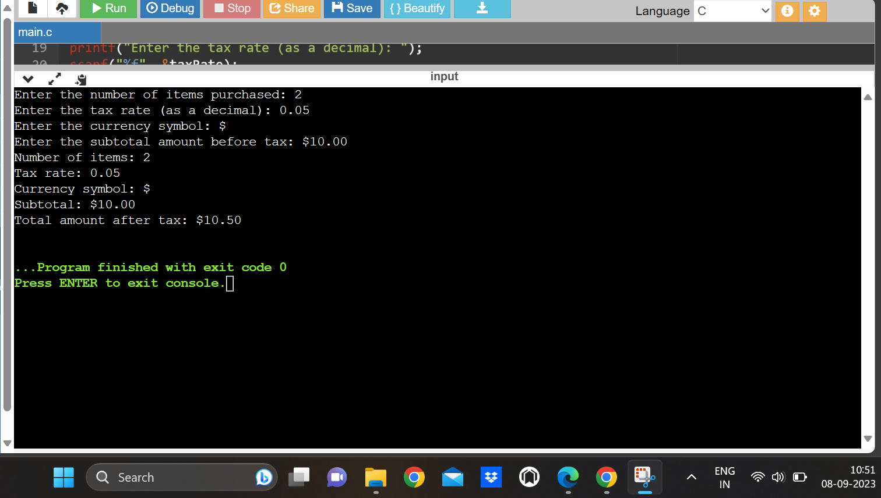

**Q2) Write a C program that declares and initializes six variables of different data types: int, float, char, double, long, short, unsigned, and signed. The int variable should store the age of a person in years, the float variable should store the height of a person in meters, the char variable should store the first letter of the person’s name, the double variable should store the weight of a person in kilograms, the long variable should store the phone number of the person, the short variable should store the zip code of the person’s address, the unsigned variable should store the number of pets owned by the person, and the signed variable should store the difference between the person’s income and expenses in dollars. The program should also print the values of these variables using the appropriate format specifiers in the printf() function. For example, %d for int, %f for float, %c for char, %lf for double, %ld for long, %hd for short, %u for unsigned, and %d for signed. Hint: - Assume that the age is 25, the height is 1.75, the first letter of the name is ‘R’, the weight is 65.5, the phone number is 9876543210, the zip code is 12345, the number of pets is 2, and the difference between income and expenses is -500 are the inputs taken from user.**

**The output will be as shown below: -**

**The age of the person Is 25 years**

**The height of the person is 1.75 meters**

**The initial of the person’s name is R**

**The weight of the person is 65.5 kilograms**

**The phone number of the person is 9876543210**

**The zip code of the person’s address is 12345**

**The number of pets owned by the person is 2**

**The difference between income and expenses of the person is $-500**

CODE:

#include <stdio.h>

int main()

{

int age;

float height;

char firstLetter;

double weight;

long phoneNumber;

short zipCode;

unsigned numPets;

signed incomeExpensesDiff;

printf("Enter age in years: ");

scanf("%d", &age);

printf("Enter height in meters: ");

scanf("%f", &height);

printf("Enter the first letter of the name: ");

scanf(" %c", &firstLetter);

printf("Enter weight in kilograms: ");

scanf("%lf", &weight);

printf("Enter phone number: ");

scanf("%ld", &phoneNumber);

printf("Enter zip code: ");

scanf("%hd", &zipCode);

printf("Enter number of pets: ");

scanf("%u", &numPets);

printf("Enter income - expenses in dollars: ");

scanf("%d", &incomeExpensesDiff);

printf("Age: %d years\n", age);

printf("Height: %.2f meters\n", height);

printf("First letter of name: %c\n", firstLetter);

printf("Weight: %.2lf kilograms\n", weight);

printf("Phone number: %ld\n", phoneNumber);

printf("Zip code: %hd\n", zipCode);

printf("Number of pets: %u\n", numPets);

printf("Income - Expenses: $%d\n", incomeExpensesDiff);

return 0;

}

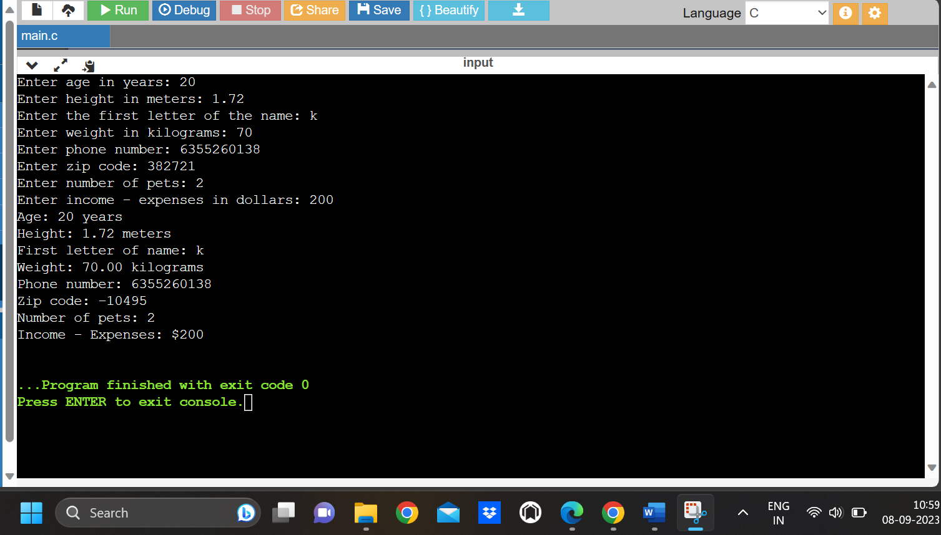

**Q3) A five-digit number is entered through the keyboard. Write a program to obtain the reversed number and to determine whether the original and reversed numbers are equal or not.**

CODE:

#include <stdio.h>

int main() {

int originalNumber, reversedNumber = 0, remainder;

printf("Enter a five-digit number: ");

scanf("%d", &originalNumber);

if (originalNumber < 10000 || originalNumber > 99999)

{

printf("Please enter a valid five-digit number.\n");

return 1;

}

int temp = originalNumber;

while (temp != 0)

{

remainder = temp % 10;

reversedNumber = reversedNumber * 10 + remainder;

temp /= 10;

}

if (originalNumber == reversedNumber) {

printf("The original number %d is equal to its reverse %d.\n", originalNumber, reversedNumber);

}

else {

printf("The original number %d is not equal to its reverse %d.\n", originalNumber,

reversedNumber);

}

return 0;

}

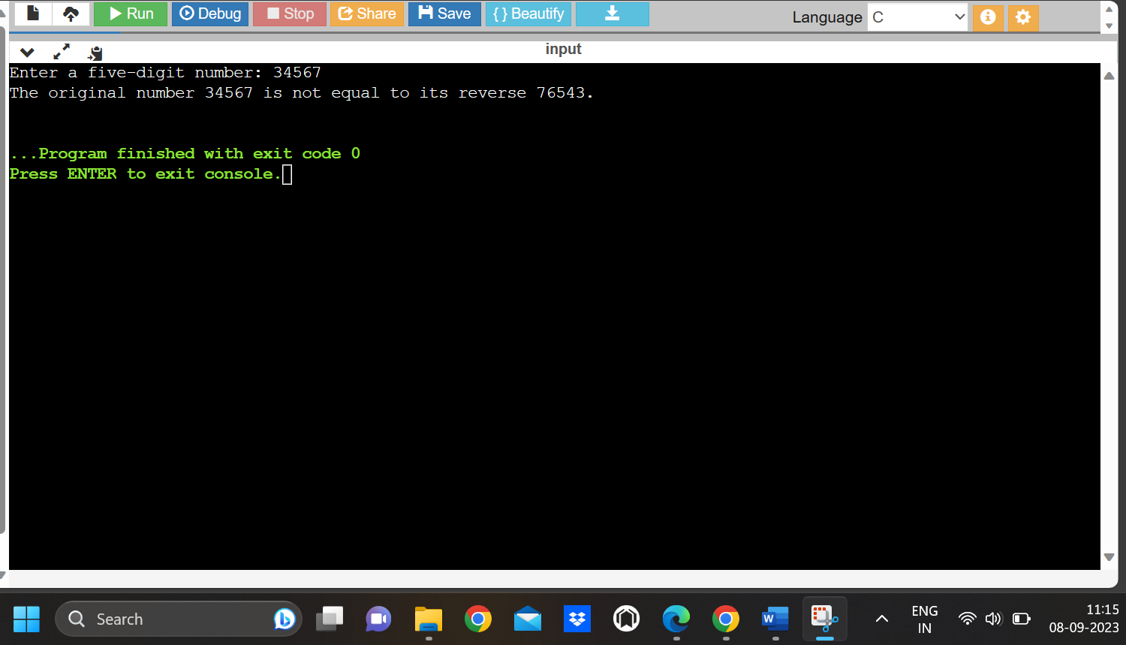

**Q4) Write a program to check whether a triangle is valid or not, when the three angles of the triangle are entered through the keyboard. A triangle is valid if the sum of all the three angles is equal to 180 degrees.**

#include <stdio.h>

int main()

{

float angle1, angle2, angle3;

printf("Enter the first angle in degrees: ");

scanf("%f", &angle1);

printf("Enter the second angle in degrees: ");

scanf("%f", &angle2);

printf("Enter the third angle in degrees: ");

scanf("%f", &angle3);

if (angle1 + angle2 + angle3 == 180.0)

{

printf("The triangle is valid.\n");

}

else {

printf("The triangle is not valid.\n");

}

return 0;

}

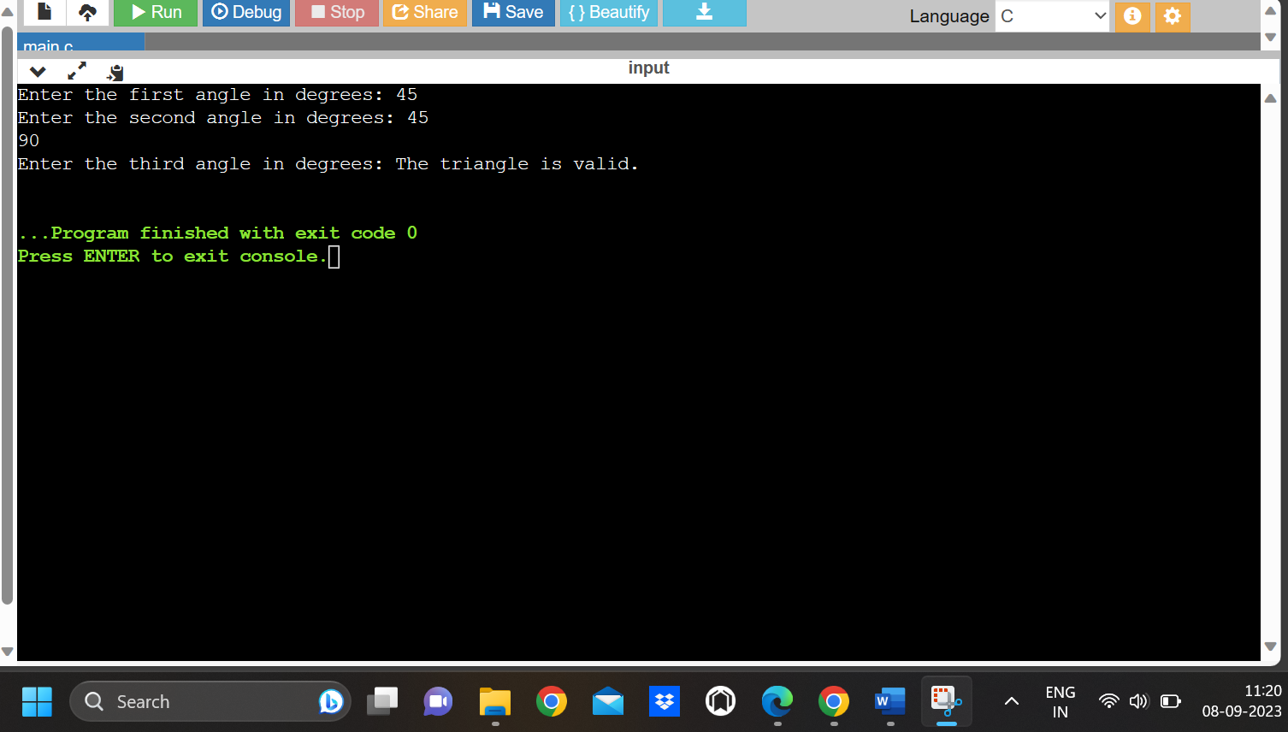

**Q5) Check whether a given character is a lowercase character or upper-case character and also print whether it is a vowel or a consonant.**

CODE:

#include <stdio.h>

#include <ctype.h>

int main()

{

char ch;

printf("Enter a character: ");

scanf("%c", &ch);

if (islower(ch))

{

printf("Lower case letters. \n");

}

if(isupper(ch))

{

printf("Uppercase letters. \n");

}

if (isalpha(ch))

{

ch = tolower(ch);

switch (ch)

{

case 'a':

case 'e':

case 'i':

case 'o':

case 'u':

printf("The character is a vowel.\n");

break;

default:

printf("The character is a consonant.\n");

break;

}

}

else

{

printf("The character is not an alphabet.\n");

}

return 0;

}

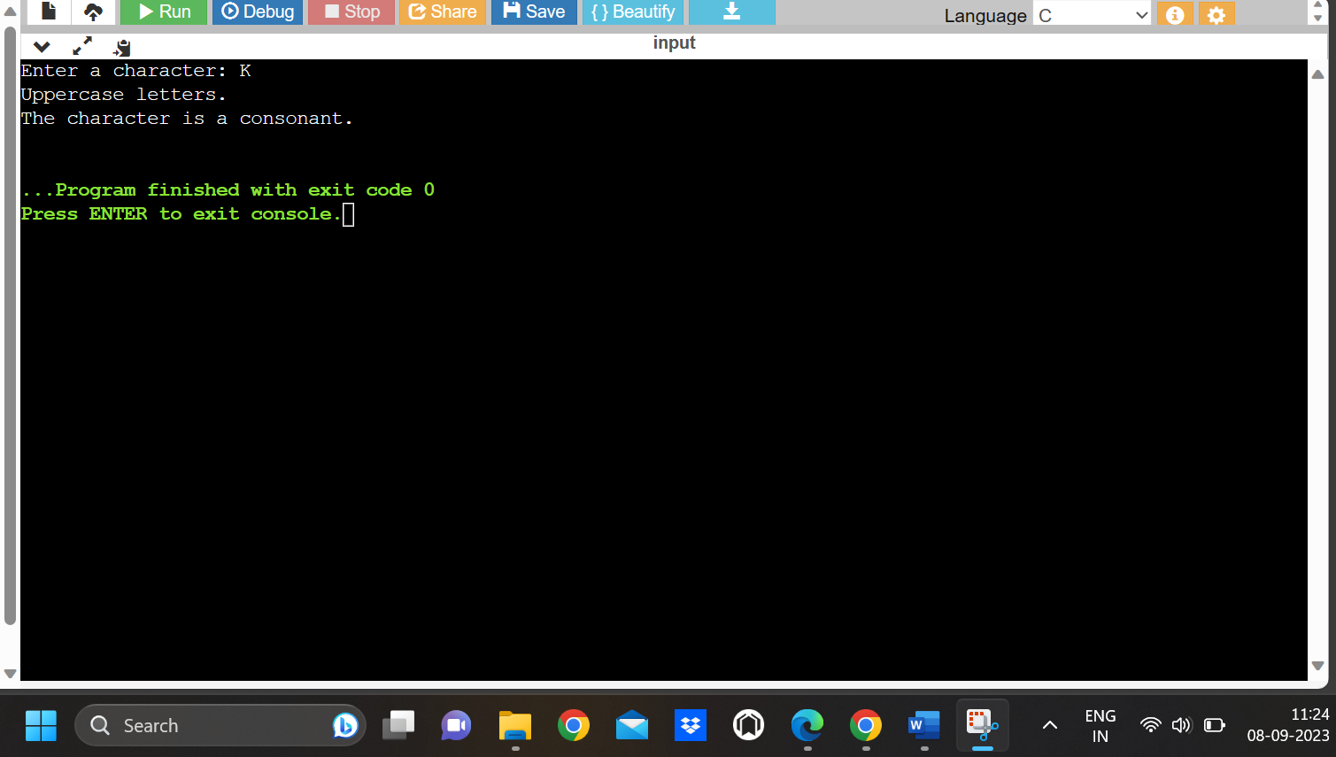

**Q6) Jhon was fascinated by geometric shapes. He drew a large equilateral triangle on a piece of paper and divided it into 9 smaller congruent equilateral triangles. If each small triangle had a side length of 2 inches, what was the perimeter of the large triangle? Write a C program for the given problem.**

**CODE:**

#include <stdio.h>

int main()

{

float sideLength = 2.0;

float largeTrianglePerimeter;

largeTrianglePerimeter = 3 * sideLength * 3;

printf("Perimeter of the large equilateral triangle: %.2f inches\n", largeTrianglePerimeter);

return 0;

}

